Monopoly
DEFINITION

Monopoly is a market structure in which there is a single seller, there are no close substitutes for the commodity it produces and there are barriers to entry.

The main causes that lead to monopoly are the following.

Firstly, ownership of strategic raw materials, or exclusive knowledge of production techniques.

Secondly, patent rights for a product or for a production process.

Thirdly, government licensing or the imposition of foreign trade barriers to exclude foreign competitors.

Fourthly, the size of the market may be such as not to support more than one plant of optimal size. The technology may be such as to exhibit substantial economies of scale, which require only a single plant, if they are to be fully reaped. For example, in transport, electricity, communications, there are substantial economies which can be realized only at large scales of output. The size of the market may not allow the existence of more than a single large plant. In these conditions it is said that the market creates a `natural' monopoly, and it is usually the case that the government undertakes the production of the commodity or of the service so as to avoid exploitation of the consumers. This is the case of the public utilities.

Fifthly, the existing firm adopts a limit-pricing policy, that is. a pricing policy aiming at the prevention of new entry. Such a pricing policy may be combined with other policies such as heavy advertising or continuous product differentiation, which render entry unattractive. This is the case of monopoly established by creating barriers to new competition.

DEMAND AND REVENUE

Since there is a single firm in the industry, the firm's demand curve is the industry demand curve. This curve is assumed known and has a downward slope (figure 6.1). We will use a linear demand function for simplicity.
The demand equation, ceteris paribus, is

X = b_{o} ─ b₁P

The clause ceteris paribus implies that all the other factors (such as income, tastes, other prices) which affect demand are assumed constant. Changes in these factors will shift the demand curve.

The slope of the demand curve is

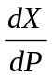 = ─ b₁
The price elasticity of demand is

e_{p} = . 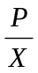 = ─ b₁ .

That is, elasticity changes at any one point of the demand curve.
(a) At point D the elasticity approaches infinity
e_{p} = ─ b₁ . → ∞
(b) At point D' the elasticity is zero

e_{p} = ─ b₁ . = ─ b₁ . 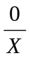 = 0

(c) At the mid point C the price elasticity is unity
e_{p} = ─ 1

The total revenue of the monopolist is

R = P.X

Solving the demand equation for P we may rewrite the price equation as

P = b_{o} ─ b₁X
Substituting into the revenue equation we find
R = P.X = (b_{o} - b₁ X). X

or R = bo.X ─ b₁ X²

The average revenue is equal to the price:

AR = 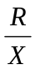 = 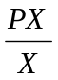 = P = b_{o} ─ b₁X

Thus the demand curve is also the AR curve of the monopolist.

The marginal revenue is:

MR = 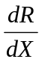 = 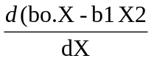 = b₀ ─ 2b₁X

That is the MR is a straight line with the same intercept as the demand curve, but twice as steep.

The general relation between P and MR is found as follows. Given

R = P.X

MR = = P.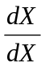 + X. 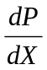
or, MR = P + X.

The marginal revenue is at all levels of output smaller than P, given that

P = MR ─ X.
The relationship between MR and price elasticity e is
MR = P ( 1 ─ )
Proof:
We know that
MR = = P + X.

The price elasticity of demand is defined as

e_{p} = ─ .
Inverting this relation we obtain
= ─ . 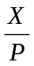

Solving for dP/dX we find

= ─ .
Substituting in the expression of the MR we get

MR = P + X (─ . )

or MR = P ( 1 ─ )

COSTS:

In the traditional theory of monopoly the shapes of the cost curves are the same as in the theory of pure competition. The A VC, MC and ATC are U-shaped, while the AFC is a rectangular hyperbola. However, the particular shape of the cost curves does not make any difference to the determination of the equilibrium of the firm, provided that the slope of the MC is greater than the slope of the MR curve (see below).

EQUILIBRIUM OF THE MONOPOLIST
SHORT-RUN EQUILIBRIUM

The monopolist maximizes his short-run profits if the following two conditions are fulfilled:

Firstly, the MC is equal to the MR.

Secondly, the slope of MC is greater than the slope of the MR at the point of intersection.

In figure 6.2 the equilibrium of the monopolist is defined by point E, at which the MC intersects the MR curve from below. Thus both conditions for equilibrium are fulfilled. Price is P_{M} and the quantity is X_{M}. The monopolist realises excess profits equal to the shaded area AP_{M}CB. Note that the price is higher than the MR.
In pure competition the firm is a price-taker, so that its only decision is output determination. The monopolist is faced by two decisions: setting his price and his output. However, given the downward-sloping demand curve, the two decisions are interdependent. The monopolist will either set his price and sell the amount that the market will take at it, or he will produce the output defined by the intersection of MC and MR, which will be sold at the corresponding price, P. The monopolist cannot decide independently both the quantity and the price at which he wants to sell it. The crucial condition for the maximisation of the monopolist's profit is the equality of his MC and the MR, provided that the MC cuts the MR from below.

A numerical example
Given the demand curve of the monopolist

X=50-0.5P

which may be solved for P

P=100-2X
Given the cost function of the monopolist
C=50+40X
The goal of the monopolist is to maximise profit
π=R-C

(i) We first find the MR

R=XP=X(100-2X)

R=100X-2X^{Z}

MR = = 100 – 4X

(ii) We next find the MC

C=50+40X

MC = 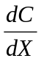 = 40

(iii) We equate MR and MC
MR = MC
or,100-4X=40
or,X=15

(iv) The monopolist's price is found by substituting X = 15 into the
demand price equation
P=100-2X=70

(v) The profit is

π = R - C = 1050 - 650 = 400

This profit is the maximum possible, since the second-order condition is satisfied:

(a) From

= 40

we have

d²C/ dX² = 0

(b) From

= 100 – 4X

We have

d²R/ dX² = ─ 4

Clearly ─ 4 < 0

There is no unique supply curve for the monopolist derived from his MC.

One point should be stressed here. The MC curve is not the supply curve of the monopolist, as is the case in pure competition. In monopoly there is no unique relationship between price and the quantity supplied. Now re-examine the statement that there is no unique supply curve for the monopolist derived from his MC. Given his MC, the same quantity may be offered at different prices depending on the price elasticity of demand. Graphically this is shown in figure 6.3 The quantity X will be sold at price P, if demand is D, while the same quantity X will be sold at price P₂ if demand is D₂. Thus there is no unique relationship between price and quantity.
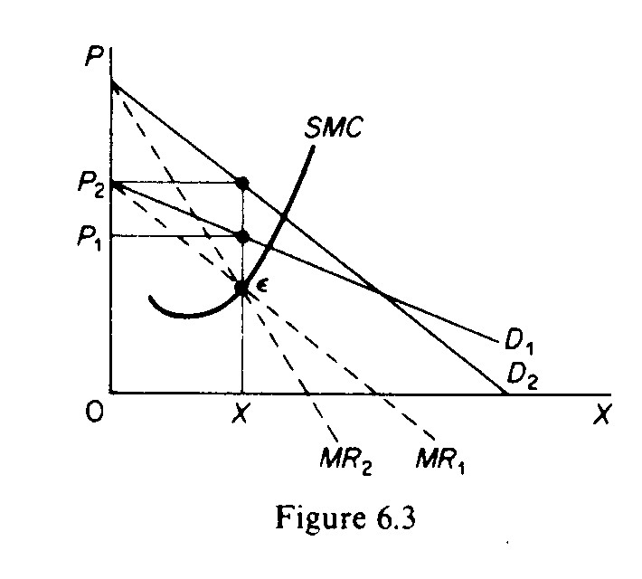

Similarly, given the MC of the monopolist, various quantities may be supplied at any one price, depending on the market demand and the corresponding MR curve. In figure 6.4 we depict such a situation. The cost conditions are represented by the MC curve. Given the costs of the monopolist, he would supply OX₁ if the market demand is D₁, while at the same price, P, he would supply only OX2, if the market demand is D₂.

